**About Neral**

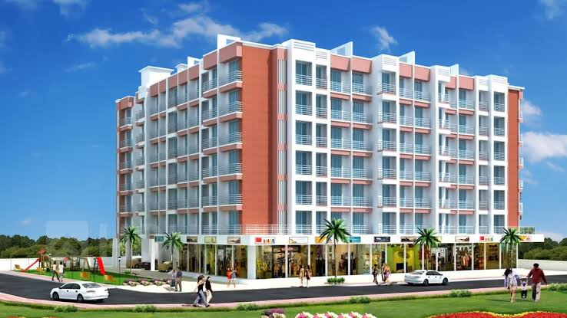

1. **Neral:-**

Neral is a town in Raigad district in the State of Maharashtra, India. This town gives a sense of happy satisfaction and enjoyable climate of evergreen and healthy environment. This pleasing town is located approximately at distance of 83 km from Mumbai-South and 42 km from Panvel. It is rapidly developing region in district, easily can connected to various regions and cities such as Panvel, Mumbai, Thane and Pune. Neral and karjat together are well known as Eastern Mumbai District.

This location is ideal for living and working for better improvement of lifestyle. The region is spread across huge area which is ideal for developing new infrastructural projects. There are various projects are developing within the region that increases the property values and demands. Nowadays people prefer to move towards Neral in the search of property, Education and Business related work. Due to increase in property values, people from other city or town attracts towards Neral because of its affordable prices as compare to metropolitican cities.

Neral offers the apartment and villas in well constructed and affordable ranges include 1BHK, 2BHK, and 3BHK.Along with these, there is various nearby facilities like Schools, Colleges, Markets, and Shopping Centers. The well connected transportation facility to various routes, as it is located close to Mumbai Metropolitan region there will be no issue related to travelling from one region to other. It is also an ideal place for weekend destination which attracts the people to various point of attractions.

1. **Transportation:-**

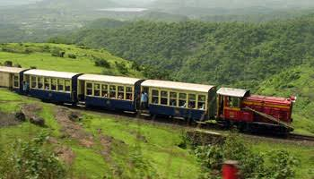

Neral has a pleasant climate with healthy and pollution free environment. This town is under Raigad district of State Maharashtra. It is about 83 km from Mumbai-South and 42 km from Panvel in the Karjat tehsil. It is a rapidly developing city which is well connected to Panvel, Mumbai, Thane and Pune. Region which Connects from Neral to Karjat is well known as Eastern Mumbai District. This place, Neral is located between Mumbai and Pune; it has State Highways which is connecting to karjat, NH4, Panvel and Badlapur. People from South Mumbai can take Panvel route to visit Neral; it is best and fastest way to drive.

Neral is populated region, facilities with various modes of transportation services such as MSRTC buses, 6-seater mindors, 3- seater auto rickshaw and 6- seater vans. Neral is famous for railroad junction, trains arriving from Mumbai and from Pune to the nearby and very popular hill station of Matheran. A narrow-gauge rail line, 21 km long, i.e. toy train runs from Neral to Matheran. Nearest major towns are Badlapur and Karjat. The nearest Airport such as Chhatrapati Shivaji International Airport and the Navi Mumbai International Airport is the nearest airport.

1. **Upcoming New Projects in Neral**

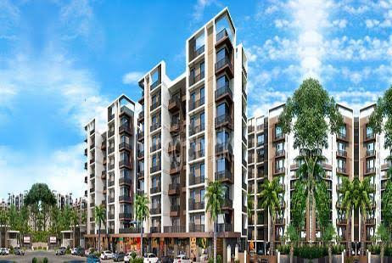

The Neral is one of the famous housing destinations for people to live a pleasant lifestyle in an evergreen environmental climate. There are several industrial hubs and holiday spots that make it a good area of investment in a residential property. As this location is outskirts from Mumbai, so it has huge scope for development and increases in prices.

There are newly upcoming projects are developing within the Neral. The people who are wants to move from crowd metropolitan city to pleasant environment region like Neral they have a wonderful choice to live in a desire home with comfort lifestyle. The Neral offers 1,000 sqft apartment for only Rs.30-40 lakhs, if the same apartment, you will find at range of several crores in Metropolitican city like Mumbai. The prices are very much high that buying apartment in Mumbai is difficult. It is good to move towards Neral because of its fast-paced infrastructure development and emerging real estate projects. It becomes a destination choice for Mumbaikars which is well connected and requires two hours to reach Mumbai from Neral. The state highway smoothly flows across Panvel, Karjat, Badlpur and National highways. The Major Highways such as Mumbai-Pandharpur Road and Mumbai-Pune Highway are seamlessly connected to reach Neral. People who travel between Neral and Mumbai prefer to take the route that goes via Panvel.

The newly and Upcoming projects constructed by well-known developers with high-tech materials include 1BHK, 2BHK, 3BHK and villas with full-equipped amenities and facilities. These projects are developed by the developers such as Olympeo, Rajwada Corporation, Vijay Estate, Tulsi Estate and many more offers residential properties in Neral. Tulsi Estate is well known real estate developers from decades providing affordable housing to their customers. Tulsi Nisarg is a project in and around Mumbai, Specifically in Badlapur, Neral, Vangani and Navi Mumbai. Tulsi Nisarg is a combination of elegant and fashionable reflection of urban lifestyle located in Neral. This project provides exclusively designed residential apartments comprises of 1 BHK and 2 BHK apartments in an affordable price range from 22 L-32 L onwards. Amenities and security features offers an array of world class amenities such as landscaped garden, CCTV Cameras, Gymnasium, Jogging track, Play area, lift, Badminton court, Skating Rink, 24hrs Backup electricity,etc.

There are many more projects are developing within the Neral which are eye-catching projects. The Morning is the new and most well-known project in Neral, developed by Signature Group in Thane District. This project is under construction offers 1-2 BHK flats with 226-438 sqft and studio apartments of 184-204 sqft in affordable ranges starting from Rs. 19 Lac onwards. This project is developed according to residential needs with necessary amenities and facilities. Another project is Shangu Prestige developed Shangu Real in Neral, Thane. Shangun Prestige is one of the residential developments of Shangu Enterprises. It offers spacious studio and 1BHK to 2 BHK apartments. The project is well developed with all facilities needed to live comfort and healthy lifestyle. These apartments are constructed under carpet area of 635-980 sqft, in an affordable range of 22.6 Lac onwards. Similarly, Tulsi Kalash, Puranik City Neral, Tulsi Darshan.

1. **Why Neral is best for real estate Investment:-**

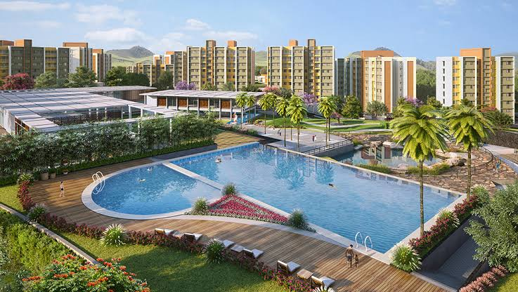

Neral is one of the fastest growing residential areas, falls under karjat Tehsil and blessed with lush greenery as Neral is surrounded by verdant hills. It is a tiny hill station with a pleasant climate, scenic natural vistas, fast-developing industries, boom in housing sector and connectivity to Mumbai and Pune makes Neral a potential investment with valuable high returns. Some of the reasons buying a flat in Neral will be a good investment, such as:

1. Ideal Place for Investment :-

Buying a flat is considered to be good investment for investors to invest in one of the ideal place like Neral, were you can expect to get high returns. If you are planning for investing in flat near Mumbai-Pune like cities, then Neral will be the right choice for you. Real estate properties in Neral is growing rapidly high due to it convenient location between Mumbai and Pune. These are the two metro cities were peoples from these cities attracts towards Neral in the search of properties because of its affordable range and evergreen evergreen environment and pleasant climate. In upcoming years, value of the flats will be definitely increases and gets high benefits in the future.

1. Affordable Range Price :-

Neral is appearing as a popular residential hub among common people because of it affordable price. Rates of flats in Mumbai are reaching high; buying the flats of desire is difficult for the common people. Neral provides good option for the people to buy the flats in affordable prices, comparatively reasonable then metropolitican city. These reasonable and affordable flats, well equipped with various modern facilities and amenities that people can buy easy. After completion of mega infrastructure of the project, the rental rates in Neral are sure to increases. According to industrial source, Neral is the next big residential hub after Badlapur and Kalyan.

1. Transport Connectivity :-

In Neral, transportation facilities are well constructed and connected to various small regions and other major areas. This city is located in between Mumbai and Karjat, were it is about 87 km away from Mumbai and 14 km from karjat. This makes a good connectivity via road and railways. In terms of road connectivity, Neral is linked to Mumbai-Pune Expressway, Pune highways, Nashik Highways, Goa Highways and state highways. By using private and public transportation, people can connect to various routes to reach from one region to other. In the form of public transport, there are various options for the peoples such as Buses, auto and many more as per convenient. Neral is served as railway station which connects to Mumbai metropolitican city. The nearest airport is Chhatrapati Shivaji International Airport and Navi Mumbai International Airport.

1. Huge Demand for Rental Flats :-

There is Huge Demand for Rental flats, as Neral is famous for Educational Institutes and situated between financial capital of Maharashtra, Mumbai, Pune and IT hub. There are various Educational Institutes that students search for the rental apartment nearer to their College. Same goes for the employees who migrate to city because of work, they also search for flats in rent. If you are planning to give a flat for rent, then you can easily get tenants in Neral. There is a huge demand for rental flats among migrants, students and employees. This will be good side business and can start generating rental income almost immediately after taking possession. This will give a good earning income from it.

1. Beauty Of Neral :-

Beauty of Neral is also the one of the beautiful reason which attracts the people to live in pleasant climate having a beautiful scenery, mountains, ancient caves and forts. It is famous for adventure sports like trekking, waterfall climbing, rappelling and river rafting. The people who planning to spend weekends and enjoy holidays can plan to visit the Neral for gaining the wonderful experiences. There are beautiful places to visit such as Kondana Caves, Peth fort, Jain Temple, Ulhas Valley, Kondeshwar temple, Bhor Ghat, Bahiri cave, ND Studio, Blackwater of Pali Bhutivali Dam, Bhivpuri waterfall. There are various restaurants, hotel rooms with delicious food cuisines, etc. The town facilities with all amenities that provides peaceful and beautiful place to spend some time away from out bust scheduled life. This all makes Neral one of the favorite holiday destinations for the peoples.

1. Education:-

In Educational Sector, Neral and its nearby regions like Karjat and Badlpur have many School, Colleges and Institutions. There are many reputed Schools offers State as well as CBSE syllabus such as L.A.E.S English High School, Vidya Vikas Mandir. Dilkap College of Engineering and SAV Acharya Institutes of Management studies are available for higher studies within a region. You also find Medical, Pharma Colleges, Boarding Schools and Specialized Training Centres. Some of the notable ones in Karjat are The Asian Institute of Communication and Research (AICAR) Business School, Indian Institute of Geomagnetism, Biotech Research Institute, Vocational Training Institute, Anglo Eastern Maritime Academy, Tata Cancer Medical Institute and Research and L & T Construction Skill Training Institute.

1. Job Opportunities:-

Many Industrial Areas are developing within the Thane district have good employment potential and they have easy access from Neral. Distance of 100 km is no barrier for people seeking employment. There are been and still are many people from Pune commute over 2 hours by train to work in Mumbai. Development of Industrial, great job opportunity and reduce the train travelling time. People in search of Job, shift to the Neral region which increases the property sales and rental opportunities.

1. Shopping and Entertainment :-

Neral is developing area, shopping, retail shops and hospitals are coming up here. There are small retails shops are available, but for major shopping would be in Karjat. The Neral is well connected by road and suburban railway with commercial and industrial areas from Badlapur to Kalyan, thane, Navi Mumbai. For Entertainment, people can also visit various point of attraction within the Neral and downside of Karjat. Many Cinema Halls and Resorts are available such as Mahesh Cinema Hall, Salunke Hall,Tapal Wadi Waterfall, Aanandi Farm and Resort, Magica Water park and many more options are available for enjoying the weekends with family and friends.

1. Hospitals and Health Care :-

For Healthcare related issues, residential has no major problems because within region their you will find hospitals, Clinics and dispensaries are available. There are government hospital and private sector clinics are within the region for taking care of residential peoples in localities.

For major treatment people can have other options in nearby regions like Karjat, Baldpur, Kalyan, and Thane. This regions can easily access via Road and Railway facilities. Some of the Hospitals and Clinics are Morya Hospital, Sugwekar Clinic, Sai Hospital Neral, Dhanvantari Hospital, Dentocare Dental Clinic, Raigad Hospital and Research Centre etc.

**Real Estate Development in Neral:-**

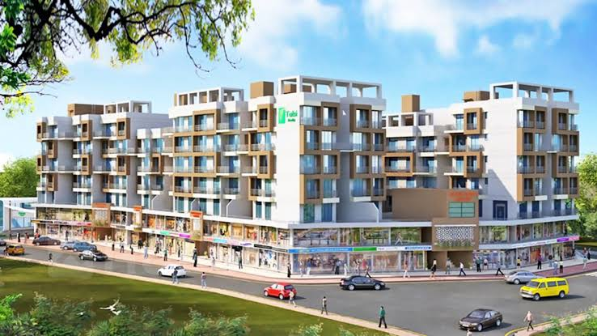

People form Mumbai-Pune like Metro cities, move towards Neral as it is point of attraction for the people. Its massive development within the region in the form of real estate projects in an affordable price range. The prices for residential property within the Neral region are presently affordable that provides area of 2,500-3000 persqft. There is ample scope for appreciation, since Thane, Kalyan-Dombivli and Ulhasnagar are inching towards saturation. People working in this area are now looking to buy houses at affordable rates. This extends a huge opportunity for developers to invest in real estate properties who can expect high returns after re-selling within five years.

Neral is easily accessible from Pune (92km), Mumbai (90km) and Navi Mumbai (40km). It has huge potential for development and price appreciation, particularly once the four-lane state highways 38 becomes operational which will substantially reduce the travel time between Neral and Mumbai. The upcoming development projects of MMR reduce the distance between cities and improve their connectivity to Neral. This Trans Harbor link between Sewri, Mumbai and Navi Mumbai reduces the distance. Additionally, two-lane and four-lane highways between Badlapur-Neral-Karjat roads will boost the connectivity of the area to commercial and industrial area of the MMR region. This improved connectivity and development attracts the foreign investor to invest within the region in upcoming year.

1. **Proximity and Landmarks near Neral:-**

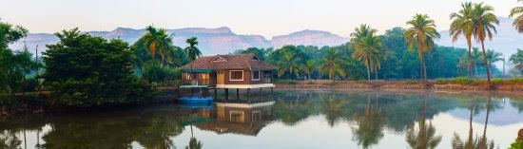

Some of the best sights and landmarks near Neral are as follows:

* Kothaligad(Peth)Fort :

Kothaligad is a small fort which is situated near karjat-murbad Raod to the east of Karjat.It is famous for treking because of its small height and easy climbing.It is also known as the fort Peth because of its base starts from peth village. There you can see small temple and large cave at the base and chimney like tunnel to the top of the fort. This pinnacle is curved from inside forming a staircase reaching the top. There is water fall at some distance from the cave and another one at the top of the fort.

* Bhimashankar Temple:

Bhimashankar Temple is a jyotirlinga shrine which is located in khed over 50km northwest near Pune. It is located 127 km from shivajinagar in the Ghat region of the Sahyadri Mountains. This temple is also famous for knowing river Bhima which flows southeast and merges with the Krishna River near Raichur. Other than these, there Trimbakeshwar jyotirlinga shrines is located near Nashik and Grishneshwar in Maharashtra.

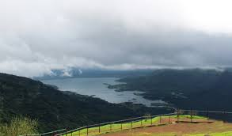

* Rambagh Point:

Rambagh Point is the most famous picnic spot that provides spectacular view of the karjat and khandal of the region. This is located nearby to the town. It makes a weekend perfect destination for a great time with your dear ones. There are many eye-catching views of mountains can be capture using cameras. This place is best to enjoy with friends, family and couples to enjoy the weekends.

* Shri Bal Digambar Ganesh Mandir:

Shri Bal Digambar Ganesh Mandir is located in kadav Karjat Town. It is a very spiritual place located in a quiet and peaceful location. Nice and simple place. There seems to be historic semblance to it’s given that there are 2/3 very old carved lying near the premise.

* Panorama Point:

For adventure seekers and photo enthusiasts, the panorama points are most attractive place in Matheran. It provides stunning view of Western Ghats and nearby towns and villages is completely breathtaking. This tranquility of the place adds the overall appeal of this site which also doubles up as an idyllic picnic spot.

* Lousia Point:

Lousia Point is one of the significant touring attractions of the goal, which gives perspectives of lovely environment. It offers wonderful perspective of old landmarks which incorporate fortresses of vishalgad and prabal. There is frequented by nature sweethearts to locate nightfall. This place is also known as photographer’s paradise in matheran, as it is famous for offers panoramic views of mountains, peaks, valleys, lake and waterfalls.

* Mountain Top Camping:

Mountain Top Camping is located at-Pavanalake, near Lonavala, Dist-Pune, Khandala, and Lonavala. Mountain Top Camping is located in Pavanalake which is nearer to Lonavala. This place one of the best places to spend weekend with friends for camping. It is an amazing to out with friends in both rainy and winter season. The waterfalls were the highlight in the monsoon and star gazing was highlight in winter. It is a bit tough but the wonderful view at the top of the fort is worth all the efforts. Also, the village food was finger licking.

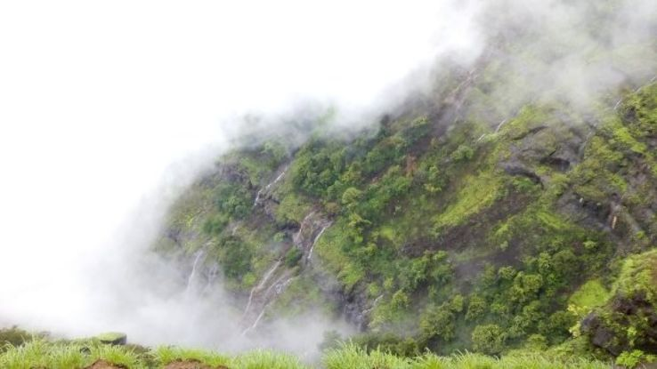

* Irshalgad Fort:

Irshalgad Fort is best place for trekking with friends which is about 3700 feet above sea level situated on a hill. It is a difficult to climb up through Irshalagad Fort trek. It takes one hour from Irshalwadi village to reach fort. The trek had been from Base Village Irshalwadi. It is located in between Matheran and Panvel in Maharashtra.

* Hart Point:

One of the famous points of interest in Matheran offers majestic views of the low lying lush plains and the greenish quite villages it is located at a distance of 2.5 km from Matheran hill station, Hart Point or Heart Point is situated on the north-western edge of the Matheran hill station. This Point offers a cool, calm and unspoiled spot for taking meditation and relaxation techniques. It is surrounded by dense green woods. It is also a favorite point of the visitor to view a beautiful sunrise from the location.This site is famous because of paradise for nature lovers among tourist and locals.

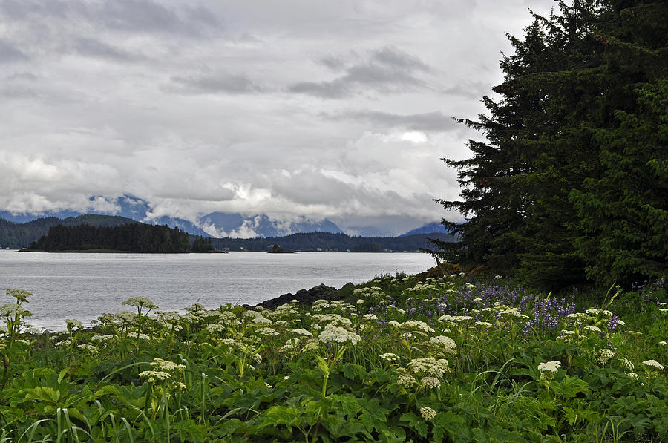

* Narayani Dham Temple:

It is religious place located in Dhankawadi area of Lonavala at a distance of 2 km from Lonavala Railway Station. This temple is dedicated to Goddness Narayani and is one of the famous places of sightseeing in Lonavala. The people from local areas and as well as tourists visit everyday owing to its famous path Dadi Mangal and bhajans that fill the air with spirituality. The temple is famous for celebrating Ganesh Chathurdi, Janmashtami and Diwali festivals with much enthusiasm. The temple has a hall huge enough to host more than 15,000 devotees. It also has a lodging facility where devotees coming from long distance can easy stay and take rest.

1. **Connectivity to Neral and New Development:-**

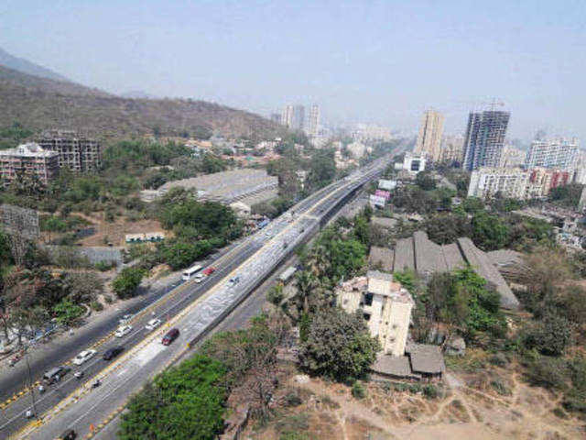

As compared to surrounding areas like Karjat, Badlapur and Ambernath which are all in the region of an average of INR 3100 plus per sq.ft. Neral is affordability, it provides under INR 3000 sq.ft. It is expected that prices will come down further, according to real estate sources as a result of the current demonetization by the government.

* Neral is well connected by State highway to various areas like Karjat, Badlapur and Panvel.
* Nearest railway station is Neral which is just at 5 minutes away.
* For Matheran, visitor can get a mini train from Neral Station. It requires only 20 mins of travelling to reach Matheran Hill station.
* People who want to connect Mumbai-Pune Express Highway; they can easily connect to it, by just of 25 mins of Drive.
* The nearest Airport is Navi Mumbai International Airport which requires just 45 minutes of Drive to reach.

In Upcoming year, there are planning and implementing by Mumbai Metropolitan region development authority and City and Industrial Development Corporation (CIDCO).Firstly, the area has been given minimal FSI of 1.0. Within the area there is recreation centre is also proposed to be developed, along with a 20-20 league playground and a golf course.

To boost connectivity to the commercial and industrial pockets of the region, government has recently approved for development for Neral-Bhimashankar highways. Infrastructure is expected to improve the roadway which connects to Navi Mumbai Airport, expansion of JNPT and the proposed Mumbai Trans-Harbour Link. To reduce the distance between Mumbai and Neral there are planning to develop four-lane state highway 38 from chowk to karjat and State Highway 54.In addition to these projects, newly four-lane highway is being built between Badlapur and Karjat location which reduces time travelling and distance.

The real estate development within the region acts as catalyst.”Residential, Commercial and large self-sustained townships’ have launched in these locations. The four mode of transport connectivity such as rail network, state highways and the upcoming airport and water transport facilities will boost and improve the standard of living of the people in the region.